Automated Openable Glass Access Roof System
An automated hydraulic openable glass roof system is a modern architectural solution used for terrace access, skylights, ventilation, and luxury roof enclosures.

Reference Roof System
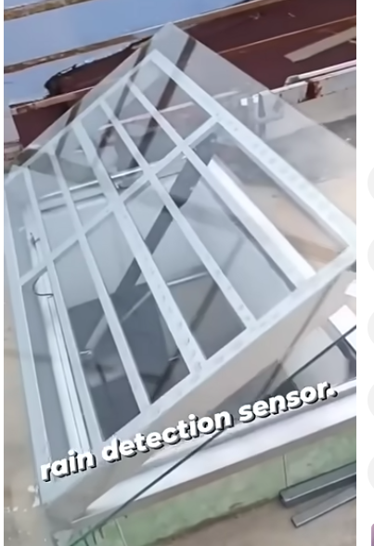

Applications
- Residential terrace access systems
- Luxury villa skylights
- Commercial atrium roofs
- Swimming pool covers
- Industrial smoke ventilation systems
- Basement daylight skylights
- Roof access hatches

Major Components
- Structural Frame: Fabricated using MS tube, aluminum sections, or SS sections.
- Glass Panels: Toughened laminated glass or polycarbonate sheets.
- Hydraulic Cylinder: Provides lifting force for opening and closing.
- Hydraulic Power Pack: Contains motor, oil tank, valves, and pump.
- Rain Sensor: Automatically closes the roof during rain.
- Limit Switches: Stops cylinder motion at predefined limits.
- Control Panel: Controls automation, safety, and manual operation.
- Sealing System: EPDM gasket and waterproof silicone sealing.

Design Considerations
- Self weight of glass and structure
- Wind load and uplift
- Rainwater drainage
- Cylinder mounting geometry
- Opening angle requirement
- Power pack capacity
- Emergency manual operation
- Safety locking mechanism
- Waterproofing and gasket compression

Basic Hydraulic Calculations
Cylinder Force Formula:
Force = Pressure × Piston Area
Opening Force Requirement:
Required Force = (Roof Weight × CG Distance) / Cylinder Distance

Typical Technical Specifications
Parameter | Typical Value
Glass Thickness | 8+8 mm / 10+10 mm
Cylinder Pressure | 80–150 bar
Opening Angle | 30° to 90°
Frame Material | MS / Aluminum / SS
Control Voltage | 24V DC / 230V AC
Protection | IP65 Outdoor Protection

Basic Hydraulic Opening Schematic
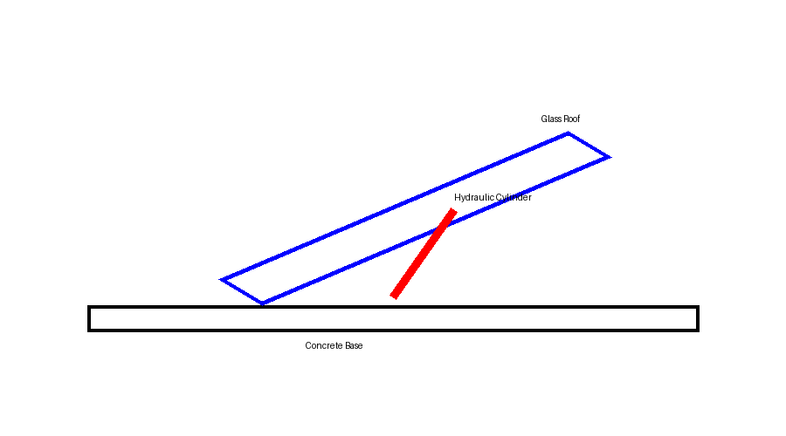

Working Principle
- User gives OPEN command through switch or remote.
- Hydraulic motor starts and pressurized oil enters cylinder.
- Cylinder extends and lifts the glass roof.
- Limit switch stops motion at desired opening angle.
- Rain sensor automatically sends CLOSE command during rain.
- Cylinder retracts and roof closes safely.

Advantages
- Modern premium appearance
- Automatic weather protection
- Natural daylight entry
- Improved ventilation
- Remote and sensor-based operation
- Heavy load lifting capability
- Smooth and silent operation

Safety Features
- Pressure relief valve
- Emergency stop button
- Manual lowering system
- Anti-fall locking
- Overload protection
- Limit switches
- Weatherproof electrical enclosure

Maintenance Recommendations
- Check hydraulic oil level every 6 months
- Inspect gasket condition periodically
- Lubricate hinges and pivots
- Check rain sensor functionality
- Inspect hydraulic hose leakage
- Verify electrical safety connections

Conclusion
Hydraulic automated glass roof systems are ideal for premium architectural projects requiring weather protection, automation, safety, and aesthetic appearance.

